**Methodology:**

The Assignment is based on “**Superstore_Canada.xls**” Dataset. In this Dataset we have information about Sales with their Customers, Products, sales details information.

**Dashboard / Output**

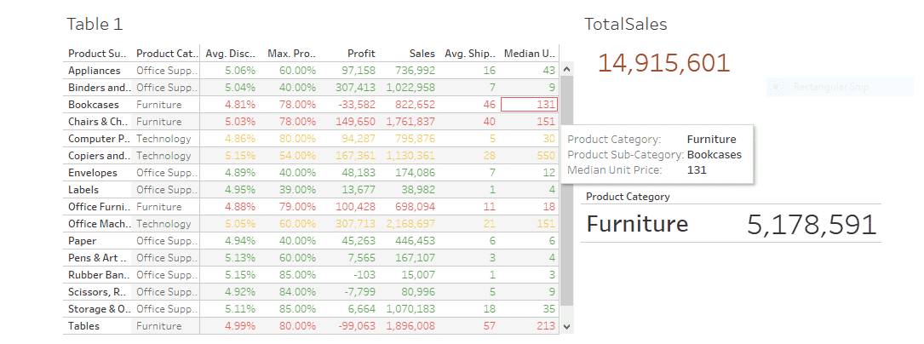

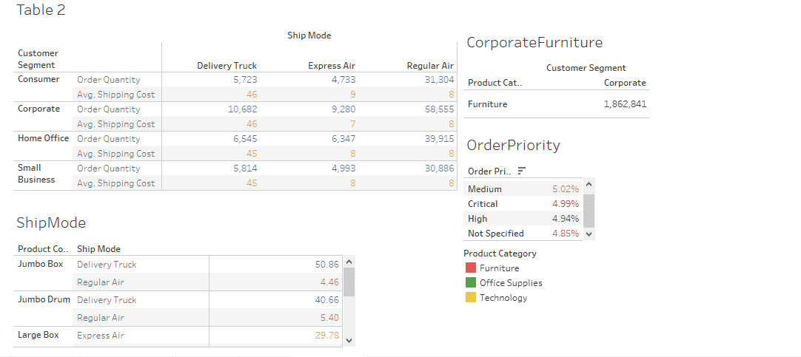

**Quiz Answer**

**A. What is the total sales of the store? (Ans–14,915,601)**

**B. What is the total sales of product category = “Furniture”? (Ans–5,178,591)**

**C. What is the total sales of product category = “Furniture” sold to Customer Segment = “Corporate”? (Ans–1,862,841)**

**D. Set the number format of Discount to percentage with 2 decimal places.**

**E. What order priority has highest average discount? (Ans–Low at 5.04%)**